MONOCHROMATIC PROGRAM

Supply List

1. Paint – Gamblin Radiant White, Winsor & Newton Ivory Black, Winsor &
Newton Burnt Umber

- Palette-wood or glass is preferable, but a paper palette is acceptable (if you get the Sta-Wet palette mentioned below, make sure your palette fits the container)

- Masterson Sta-Wet palette – optional, but it definitely comes in handy when carrying a palette with wet paint

- Palette knife

- Palette cups (2 single cups are best-1 for spirits, 1 for medium)

- Gamblin Gamsol or odorless mineral spirits (for brush cleaning)

- Winsor & Newton English Distilled Turpentine – 75ml bottle

- Winsor & Newton Cold-pressed Linseed oil – 75ml bottle

- Winsor & Newton Liquin – 75ml bottle

- One 2oz tube of Golden acrylic, N7 Neutral Gray

- Firm brushes – Robert Simmons Signet bristle round brushes, sizes 1,2,4 –
get at least 3-5 of each size

- Firm brushes – Robert Simmons Signet bristle filbert brushes, sizes 2,4,6 –
get at least 3-5 of each size

- Soft brushes-Raphael 867 Kevrin rounds, sizes 4 & 6 - get at least two of each size

- Vine charcoal-medium

- Sanding block (for sharpening charcoal/pencils)

- Pencils and general drawing materials

- Notebook

- Canvas (I will give an extensive list of sizes when you begin)

19. Two wooden paint stirrers - (pick up at any paint store)

20. Roll of paper towels

21. Three (3) small glass jars, either ¾ oz or 2 oz

22. 2” house painting brush (for canvas priming)

Art supply web sites-
www.dickblick.com
www.aswexpress.com
www.jerrysartarama.com

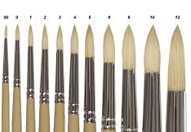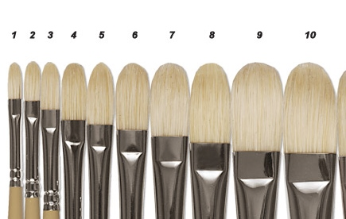
Robert Simmons Signet Rounds Robert Simmons Signet Filberts

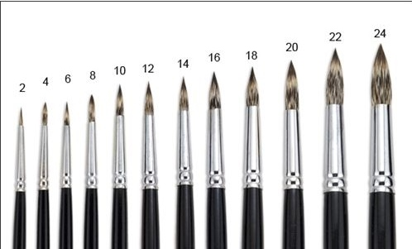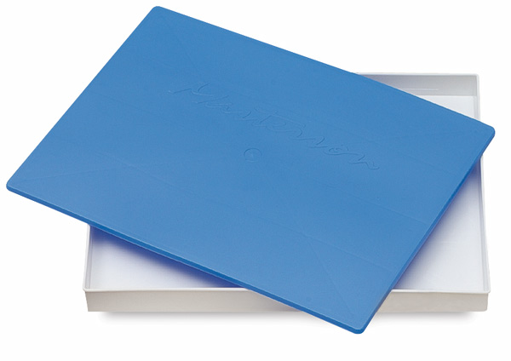
Raphael Kevrin 867 Rounds Masterson Sta-Wet Palette

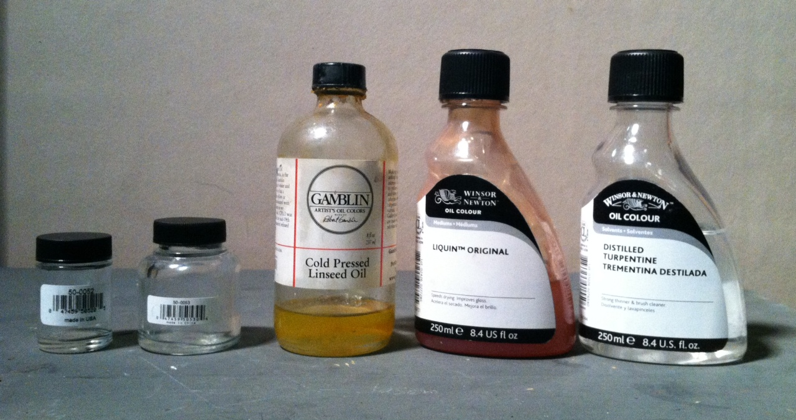
Mediums and medium jars

